Shabbos Stories for
Parshas korach 5774
Volume 5, Issue 43 23 Sivan 5774/ June 1, 2014
For a free subscription, please forward your request to keren18@juno.com

Life After Birth?

In the womb of a pregnant woman two embryos are talking. One of them is a believer, the other a non-believer:
Believer: What an incredible world we are going to!
Non-believer: What! Do you really believe in life after birth?
Believer: Yes, sure. Of course there is life after birth. We are only here in order to prepare and ready ourselves-- for what is awaiting us after this.
Non-believer: This is stupidity! There can’t be any life after birth! Can you even imagine what that kind of life could look like?

The Believer Doesn’t
Know All the Details
Believer: I don’t know all the details, but I believe that there will be more light and we will walk by ourselves and eat with our own mouths.
Non-believer: Such nonsense! It’s obviously impossible to walk by ourselves and to eat with our mouths! It’s simply ridiculous! We have an umbilical cord which feeds us. You know, I want to tell you that it is impossible that there will be life after birth, because our life, that is, our umbilical cord, is simply too short.
Believer: I’m sure that it’s possible. Everything will be a little different. It is possible to at least imagine.

But Nobody from There
Has Ever Come Back
Non-believer: But nobody from there came back! Life simply ends with birth. And, generally, life is one big suffering in darkness.
Believer: No, no! I don’t know exactly how our life will look like after birth, but, in any case, we’ll see our mommy and she will take care of us.
Non-believer: Mommy? You believe in mommy? And where, do you think, she is?
Believer: She is everywhere around us, we are in her and thanks to her we are moving and living, without her we simply cannot exist.
Non-believer: It’s totally nonsense! I don’t see any mommy, and that’s why it’s obvious that she simply doesn’t exist.
Believer: I can’t agree with you, because sometimes, when everything around is silent, it’s possible to hear her singing and to feel how she is patting our world. I firmly believe that our real life will start only after birth.
Hakhel Comment: Thank you, may we all prepare well -- and may we all soon see the great light that even we -- as believers -- cannot even fathom or imagine!

Reprinted from the June 17, 2014 edition of the Hakhel Email Community Awarness Bulletin.

A Slice of Life

Psychiatrist by Day,
Scribe by Night
By Allie Freedman

Page by page, line by line, letter by letter, Richard Epstein has spent the past eight years meticulously handwriting the words of G-d. Using a turkey feather quill and kosher animal skin parchment as his pen and paper, he masterfully created a Torah scroll for the Chabad Shul of Potomac. Running his own private practice in general psychiatry by day, Epstein, 74, devoted his nights and weekends to crafting his holy work. On Sunday, Epstein will complete his sanctified journey by penning the final of the scroll's more than 300,000 letters at a dedication ceremony at the Chabad center.
"In Deuteronomy 31:19, G-d says, 'Write for yourself this song.' That means, every Jew should write a Torah scroll," says Epstein. "It is a great honor and responsibility to inscribe the Torah.
"The first Torah scribe in the world was Moses himself," he continues. "Every time I sat down to write, I became engrossed in the work. I feel a strong sense of awe, as I am so moved by the beauty of the Hebrew letters. I am doing G-d's work. It is one of the most amazing tasks I've ever done in my life."
Living until the dawn of the 21st century a primarily secular life, the Brooklyn-born psychiatrist always felt a strong connection with the Torah, he says. He discovered Potomac's Chabad center 15 years ago and began studying the Torah with Rabbi Mendel Bluming. Throughout his studies, he immersed himself in the medieval commentary of Rashi and realized that he wanted to become a scribe.
"Rashi's teachings opened up a new world and meaning of the Torah for me," says Epstein. "After studying with Bluming, I wanted to contribute. I realized our synagogue needed a new Torah, and I knew writing the Torah would bring me closer to G-d."
Discussing his personal admiration for Epstein, Bluming says he was inspired by his longtime study partner's decision to take on the time-consuming task of writing a Torah.
"Dr. Epstein was one of the first people I met when I came to Potomac in 2000, and we began to study together regularly," says Bluming. "I was struck by his earnestness and genuine thirst for Torah knowledge and observance. His connection to learning the Torah inspired him, ultimately leading to inscribing his own Torah scroll."
Embarking on the new adventure, Epstein first had to perfect his knowledge of Hebrew scripture. He became an apprentice to a sofer [scribe] and studied the intricate laws detailing the stylizing of the Hebrew letters and the specific spellings of certain words. After practicing the art of writing the unique script of religious literature, Epstein began his side career as a scribe by working on a Megillah, since G-d's name is not included in the text. (According to Jewish law, the name of G-d is so holy, that mistakes made in its formulation can render an entire text - or sections of text - invalid for ritual use.)
Epstein then moved on to writing about a dozen parchment scrolls for placement in mezuzahs to prepare for writing G-d's name. Finally, he was ready to tackle the much larger project of writing a complete Torah scroll.
"I became so absorbed in my work," says Epstein. "Before I start writing, I say a prayer and give money to tzedakah [charity]. Then, I would say each word and each letter out loud as I wrote. After each line, I would read the line both forward and backward to ensure there were no mistakes. At this point, it would take me between 12 and 15 minutes to complete one, single line."
With 42 lines per page, Epstein uses a numbered celluloid strip to keep his place. In addition, he often writes the name of G-d in the text beforehand. If a scribe makes a mistake on G-d's name, the parchment is buried in the ground, because according to Jewish law, G-d's name cannot be thrown away. In today's hi-tech society, several computers checked the work for accuracy. In addition, the Torah was proofread four times by hand to guarantee perfection.
Epstein's act of inscribing the Torah quickly became a communitywide event at the Chabad Shul of Potomac. Throughout the past eight years, Epstein displayed each completed page of the Torah to the synagogue. He wanted the public to feel immersed in the process. In addition, Epstein has allowed some members of the community to fill in some letters of the Torah and to dedicate Torah portions.
"I feel as if I am an ambassador to helping people fulfil the mitzvah of writing the Torah," says Epstein. "As I hold the quill with members as they inscribe their letter, I watch people connect to the Torah on a new level. This is our community's Torah. I am just a regular congregant with a day job. I hope that will inspire others to fulfill mitzvot."
Once Epstein finally fills in the last letter, the synagogue will parade its brand new scroll down the streets. Joining the procession, neighboring synagogues Beth Sholom Congregation and Talmud Torah and Young Israel Ezras Israel of Potomac will bring out their own Torahs. After the parade, the synagogue will provide refreshments and a presentation on the scribal arts.
"This has been a truly transformative eight year journey for our community," says Bluming. "The extent of community excitement and involvement from day one is incredible. I never imagined how much of an impact this would have on us. Dr. Epstein has inspired many in our community to re-examine their bucket lists and expand their horizons. This is something that I want my children and the children of our community to witness and remember forever."
In celebration of the completion of the long journey, Epstein will read from his new scroll at morning prayer services on Monday. As a scribe, he plans to continue writing mezuzah scrolls and playing an active role in the Jewish community.
"Every mitzvah is a challenge and an opportunity," says Epstein. "G-d provides the Jewish people the 613 mitzvot to enhance their lives. I feel as if the Torah wrote me rather than I wrote it. I'm deeply grateful that G-d provided me this opportunity to bring his Divine light into the world with this mitzvah.

Reprinted from the recent Parshas Beha’losecha edition of “L’Chaim,” a publication of the Lubavitch Youth Organization in Brooklyn, NY. The article was reprinted with permission from the Washington Jewish Week.
Celebrating a Chattanooga
Family’s Pre-Shavuot Conversion
By Julie Wiener

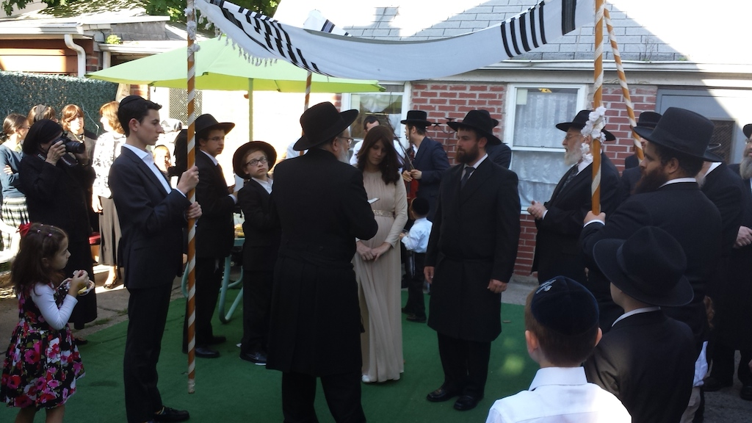The newly Jewish Sholom and Nechama McJunkin’s wedding ceremony Sunday night in Brooklyn attracted 100 people, many of them strangers. (Photo by Alexander Rapaport)

Just in time for Shavuot, with its reading of the Book of Ruth about Judaism’s first convert, a Tennessee family of 12’s conversion to Judaism has prompted an outpouring of support from Brooklyn’s haredi Orthodox community.
On Sunday, Sholom and Nechama (originally Chad and Libby) McJunkin brought their 10 children to Brooklyn to complete 12 conversions and have a Jewish wedding ceremony.
Their wedding, held in the backyard of Rabbi Tzvi Mandel’s house adjacent to his small synagogue in Brooklyn’s Kensington neighborhood, attracted 100 people. Many of the guests were gift-bearing strangers who had learned about the family through an impromptu surprise online wedding registry established Saturday night by Alexander Rapaport, executive director of the kosher soup kitchen Masbia.
The online registry, which was featured Sunday in the Vos Iz Neias website, includes various staples, such as Judaica and kosher grocery gift certificates, for the family’s newfound Orthodox Jewish life. By midday Tuesday it had raised almost $10,000 from 235 people.
In addition, the family was slated to spend Shavuot at a Stamford, Conn., hotel as guests of Gateways, a Jewish outreach organization hosting a retreat there. Meanwhile, a “Jewish-themed” toy store, Toys 4U donated a $500 store credit.
“The hospitality has been outstanding,” said Sholom McJunkin, a carpenter, in an interview with JTA.
“We’ve met so many wonderful people who have showered us with love and gifts,” he added.
The Chattanooga family’s conversions are the culmination of a lengthy spiritual journey, Sholom McJunkin said. The couple, who met in high school, were raised nominally Baptist and became more religious soon after they married.
But after a few years in the Baptist church, the McJunkins felt they weren’t getting satisfactory answers to their spiritual questions. They tried other churches, then eventually found their way to the Amish church. While living in the Amish community in rural Tennessee McJunkin said he first began reading the Hebrew Bible and learning about Judaism.
Two years ago, after leaving the Amish church, the family found the Chabad Jewish Center of Chattanooga, led by Rabbi Shaul Perlstein.
“He’s been a real inspiration to me: his love for the Torah and for the Jewish people,” McJunkin said of Perlstein. Because Chabad rabbis do not oversee conversions, the McJunkins sought out non-Chabad Orthodox rabbis in New York.
Masbia’s Rapaport told JTA he came up with the idea for the wedding registry after Dovid Tzvi Steinberg, a friend of the McJunkins who was seeking help finding a wedding venue for them, called last week and mentioned that he felt the family wasn’t getting as much support from the community as he’d hoped.
“I thought about it and called back and said, ‘We do need to show them some love,’” Rapaport said.
“Obviously people in the religious community can relate to a family with 10 children,” he said, adding that “it’s a simple wedding shower of strangers.”

Reprinted from an article of the JTA (Jewish Telegraph Agency) released on June 3, 2014.

It Once Happened

The Special Golden Coin

Long before Rabbi Meir of Premishlan was known as a tzadik (righteous person), his unusual kindness and compassion were demonstrated. Even as a young child he would go from door to door collecting money for the poor. Rabbi Meir was simply unable to bear seeing someone in an unfortunate situation. He would do everything in his power to relieve the other's suffering.
At the same time, he was extremely modest and went out of his way to avoid drawing attention to himself. A year after he was married, he hired himself out as a tutor for an estate owner's children, a common way to support one's family in those days.
It did not take Rabbi Meir long to realize that the wealthy landlord was a coarse individual. Nonetheless, the children seemed to be progressing nicely under his tutelage, despite their father's rough and boorish behavior.
Rabbi Meir was particularly distressed by his employer's stinginess. Whenever a poor person knocked on the door asking for a donation or a crust of bread, he was treated condescendingly and with a tight fist.
For the first few weeks in his new position Rabbi Meir tried to concentrate on his teaching and ignore what was happening. But as time wore on he found it increasingly difficult to restrain himself.
One day, Rabbi Meir approached the owner of the estate and made a suggestion. "From now on," he proposed, "every time a poor person comes, I'd like to you give him a coin, which you can deduct from my salary." The landlord agreed to the plan, as there was no reason for him not to.
From that day on, every beggar who arrived on the doorstep received a coin, and sometimes even a light meal to ease his hunger. In the meantime, the owner of the estate was carefully recording every penny that went to charity in his ledger. No one could understand the miserly landlord's sudden generosity, but at least the beggars were happy.
Six months passed, and soon it was almost Passover and time for Rabbi Meir to go back home. Before he left, the owner of the estate called him in to pay him his salary. Taking out his ledger, he deducted all the coins and food he had "wasted" on the poor, and was shocked to see that nothing remained. And not only that, but Rabbi Meir actually owed him money! The landlord was furious. How could he, a smart and savvy businessman, have allowed himself to fall into such a trap?
Rabbi Meir was banished from the estate without a penny in his pocket. Why, he was lucky to even have a pocket, as the landlord had briefly considered taking Rabbi Meir's overcoat as payment for the "damages" he had incurred, before changing his mind at the last second.
Rabbi Meir, however, was not particularly upset by what had occurred. In fact, he was in a good mood. Passover was coming, he was going home, and there were many things in the world more important than money...
Rabbi Meir was on the outskirts of Premishlan when something shiny in the road caught his attention. Looking closer, he saw it was a very valuable gold coin, worth far more than the entire salary he was supposed to have received as a tutor!
Rabbi Meir, however, did not think along the same lines or in the same way as "regular" people.
The whole way home his thoughts had been focused on higher, more spiritual matters. His initial reaction upon seeing the coin was hesitation. "Is this the way it has been decreed from Above that I derive my livelihood?" he thought to himself. "Does G-d really want me to make a living from the dust of the earth?" Rabbi Meir continued walking and did not bend down to pick it up.
Rabbi Meir's wife was overjoyed to see him after a half-year's absence. Several days later, when her husband still hadn't mentioned any earnings, she thought it was strange, but having full faith in him she did not bring up the subject, assuming he had his reasons.
By the following week she decided the time had come to allude, very delicately, to their financial situation. But her husband only responded cryptically, "Let's wait until tonight..." and left for the synagogue. In shul, money was soon the farthest thing from his mind.
That evening, Rabbi Meir was in the study hall when the servant of one of the wealthiest inhabitants of Premishlan suddenly tapped him on the shoulder. Handing him a gold coin he said, "My master asked me to deliver this to you."
Rabbi Meir jumped up as if bitten by a snake. "What is the meaning of this?" he inquired. The servant related that earlier that day his master had returned to Premishlan after a long journey, and had found the coin lying on the ground. After some deliberation he had decided to give it to a young Torah scholar, and Rabbi Meir's name had been drawn from a lottery.
"I see this coin really was supposed to be mine..." Rabbi Meir smiled, pondering the ways of the Creator.

Reprinted from the Parshas Beha’losecha edition of “L’Chaim/”

Chasidic Story #864

Patient as Hillel
From the desk of Yerachmiel Tilles
editor@ascentofsafed.com

A young man in Israel, who was not that particular about keeping the mitzvot, heard a Talmudic story about the man who made a bet with somebody that he would be able to cause Hilled the Elder to become angry. The man came to Hillel's house on a Friday afternoon when Hillel was in the bath. Time after time he disturbed Hillel with all kinds of foolish questions. Nevertheless, Hillel did not become angry.
The young man who heard this story wanted to know if the rabbis of today possess that same quality of patience. He thought to himself: "The rabbis certainly all know this story, and maybe they also use the story in their sermons. I want to find out if they indeed practice what they preach."
He prepared a telephone list with a number of important rabbis. At two o'clock in the morning he phoned up the first rabbi on the list and asked him: "What blessing do you make over an apple coated with honey?"
The answer was not long in coming: "Can't you call me at a more normal hour in order to ask questions like these??!" and the rabbi slammed the receiver.
Our acquaintance continued to phone up rabbi after rabbi, call after call. The reactions were all the same, indignation for waking them up in the middle of the night for such a minor matter.
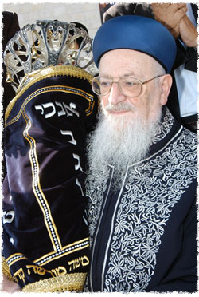
Around three o'clock in the morning he called the former Sephardic chief rabbi, Rabbi Mordechai Eliyahu.
When the rabbi picked up the phone, the man asked: "Can I ask you a halachic question?"
"Certainly", the rabbi replied. "Just tell me if the question can be delayed until I'll wash my hands."
The young man agreed, and after a short while the voice of Rabbi Eliyahu could be heard: "Yes, I'm ready to listen."
When the man presented his inquiry concerning the sugar coated apple, the rabbi gave him an elaborate answer and explained to him all the halachic details involved.
Finally he added: "You may call me and ask me any question you like, and whenever you want!"

Source: Adapted/supplemented by Yerachmiel Tilles from "Chassidic Gems" by Tuvia Litzman, who heard it from a friend of the questioner.
Biographical notes: Rabbi Mordechai Eliyahu (1929-25 Sivan 2010), the former Chief Sephardic Rabbi of Israel, was born in Iraq. A noted sage in all areas of Torah study, as well as a significant kabbalist, he was considered to be one of the leading authorities on Jewish law in Israel. His son, Rabbi Shmuel Eliyahu, is currently the Chief Sephardic Rabbi of Zefat.
Connection: Seasonal-4th yahrzeit of Rabbi Mordechai Eliyahu on Sunday night - Monday, 25 Sivan (June 22-23).

Reprinted from last week’s email of KabbalaOnline.org, a project of Ascent of Safed
www.ascentofsafed.com ascent@ascentsafed.com

Rabbi Yosef Viener Discusses How to
Get Back to the Basics of Bitachon
By Daniel Keren

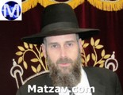

Rabbi Yosef Viener, former Rav of the Agudath Israel of Flatbush and currently mora d’asra of K’hal Sha’ar HaShomayim in Monsey recently spoke in Flatbush on the topic of “Why are We So Nervous?: Getting Back to the Basics of Bitachon to Navigate the Daily Challenges of Life.”
Rabbi Viener began his lecture by saying that he has always been bothered by the question of why the Jews were instructed by Hashem to depart from Mitzrayim with mipazon, great haste.
After all, Hashem knew exactly when the redemption from Egypt would occur. Why couldn’t the Exodus be executed in a calm manner? In explanation, Rabbi Viener noted that we find throughout Tanach that most of the miracles that Hashem performed on behalf of the Jewish people were executed at just the last second or moment possible.
Why is it so important to anticipate that Moshiach could come at any moment or at the drop of a dime? Rabbi Viener explained that if we are not trained with the belief that Hashem could change and solve our problems at a moment’s notice, we will be unable to handle the numerous challenges that routinely come up every day many times in our lives.
The Ibn Ezra says that the first of the Aseres Hadibros (Ten Commandments) is not to teach us that Hashem created the world, but rather to emphasize that He continuously supervises every second of the world’s existence.
The Rambam says that if you don’t believe in hashgacha pratis (Divine Providence in one’s life,) you are not on the team [with Hashem.] A Ben Torah who doesn’t have trust in Hashem will not have the success in his learning because of the fear of perhaps not having properly mastered what he has previously learned.
A person who worries too much about events in his life might actually cause himself to become seriously ill as a result of his lack of trust in Hashem’s ability to turn things around in a moment’s notice.
We have to be calm in our lives in order to allow ourselves to become vessels that Hashem can bestow blessings and redemptions upon. Often times, parents panic with fear that they might do things for their children’s welfare that might backfire. This important task of raising children also requires bitachon on the part of the parents.
At the end of Mesechta Makkos, Rebbi Akiva and his colleagues hear the loud sound of raucus celebration by the Roman Legionnaires near the Har Habayis where the Second Beis Hamikdosh had recently been destroyed. His colleagues are crying and Rebbi Akiva is smiling. Unable to fathom his reaction, they ask him how can he smile? And he explains that if these wicked Romans are allowed to celebrate in this world [despite have oppressed the Jews and having destroyed the Holy Temple,] how great will be the reward Hashem gives to the Jews in Olam Habah for being loyal to G-d in this world. With than answer, his colleagues were comforted.
Rabbi Viener asked “Why should you smile when walking on the streets?” The answer is because it is good for one both spiritually and physically. Furthermore by smiling you can spread joy to others insofar as the act of smiling is contagious.

Excerpted from an article in last week’s edition of the Flatbush Jewish Journal.

World Guinness Record Broken
For Largest Shabbos Meal

Chabad of Tel Aviv broke a World Guinness record Friday night when 2,236 people gathered together at Hangar 11 in the Port of Tel Aviv to join in the largest Shabbos meal ever held. Registration opened a month ago and filled to capacity within two weeks. Pravin Patel, a Guinness World Records adjudicator came in especially from London to record the event.

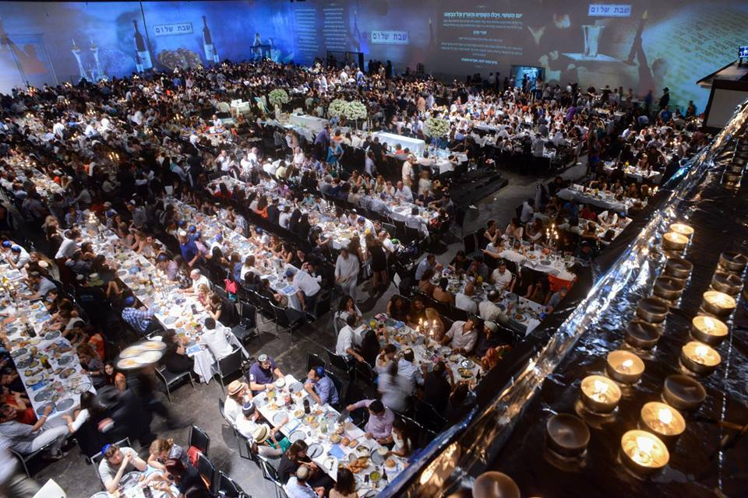

It was the first time that the Port of Tel Aviv, a known irreligious location, hosted a Shabbos observed strictly in accordance with Halacha. Thousands of students joined in the Shabbos tefillos and later made Kiddush and washed for Hamotzi that commenced before the meal. All this was done without microphones, without cell phones and without cameras keeping with the strict laws of Shabbos.
The historical event opened an hour before Shabbos with greetings from various rabbis and public figures who urged an increase in Shabbos observance in Tel Aviv.
Rabbi Joseph Gerlitzky, the Chabad head shaliach in Tel Aviv-Yafo and founder of Chabad on Campus in Israel said that this huge event proves that the youth of Tel Aviv defy the accepted notion that Tel Aviv is anti-religious and embraces Shabbat observance with open hearts. “May this event be a source of strength and encouragement to observe all other Mitzvot,” said Rabbi Gerlitzky.
Chief Rabbi of Tel Aviv Rav Yisroel Meir Lau also had high praise for the event and urged the crowd to pray for the teens who were abducted near Chevron only hours before. Special prayers were recited for their safe return.
Some 1000 women and girls were vividly moved to tears when they lit the Shabbos candles before sundown. They were assisted by the students of the Girls Seminary of Tel Aviv “Beit Shoshana”.
The MC of the event was Rabbi Zev Raskin of Cyprus. Joining the meal was former Israeli ambassador to Washington Micael Oren and T.A. Mayor Ron Chuldai.

Reprinted from the current website of Mazav.com

